Tesla Marketting

Introduction

**Facts and history of Tesla**

* Mention supporting companies (Eg:- space x )

**Development scope and revolutionizing technology**

* Tech incorporated in the car (Game feature in car )
* Safety features in car (Self driving comes as standard in all Tesla’s)
* Specification of the car (reporting with unheard figures Eg:- 0-60 in 1.9 seconds)

**Statistics**

* Advertising budgets
* Comparing with other carcompanies

**Marketing strategies and tactics**

* Through electrifing the future he hops to reduce the cost of tesla cars
* Supporting countries with reasources such as power …..

**Methodologies used compared to existing methodologies**

Eg:-

Tesla roadster to space

<https://youtu.be/tF9r9LrOb70>

<https://www.tandfonline.com/doi/abs/10.1080/0965254X.2012.657224>

<https://www.tesla.com/ns_videos/2018-tesla-impact-report.pdf>

free media promotion (provide interesting stories for media to cover)

Marketting by car reviewers on You Tube

**Solar panels generating electricity for their data warehousing.**

Solar panels generating electricity for their data warehousing and source data .

1.Tesla warehousing

Giga factory - makes cars

When it comes to producing cars Tesla plans on making solid castings all at once instead of bonding up several parts of aluminium/metal components of the car while this helps make cars much quicker it also saves up a lot of time and energy when making cars s

, solar panels

Tesla also claims to use there giga factory to make other stuff such as solar panels and etc. to power plants around the world

Battery packs

Cranks out 2 battery packs every minute

//cost advantage

Make more batteries reduce the cost to harvest the energy

//can power a home for 3 days

, and there renewable energy products in a short span of time thus reducing labour cost

and Tesla claims to reduce labour by 40%

2.Tesla renewable energy and their purpose(Future)

3.Teslas contribution(Other countries, warehousing)

Giga factory in Australia to help power shortage

Giga factory to Germany

Puerto Rico &

4.sight

<—- Tesla Gigafactory battery manufacturing plant, where Megapack batteries that will store energy for the projects will be made —>

//excess heat from the machines

//water cooling

//strives to reach zero carbon footprint

//resources ,rain access , less humidity and , direct salability

//giga New York produces the companies residential energy eg solar roof ;

**gigafactory**

With the intention of keeping up with the orders placed for there cars the giga factory was made to produce large volumes of cars and other equipment such as battery packs with the efficiency and the time saving factors put to consideration the resultant output is that both sales costs and battery pack costs have been reduced

Advantages of Giga factory

* Povered by solar panels geo thermal sources
* Uses robots mostly and other advance tech to transport items (Reduces employ hiring)

**Customization factors for customers (gigafactories) – Nilhan**

**advertising via big data - Nilhan/ Disini**

**Solution to the problems – Nilhan**

**Development scope and revolutionizing technology**

Tesla cars are knows for its efficiency and eco friendly structure that’s being encorparated into the car . Starting from the Crazy performance statistics to the technology in the car there is no wonder why people are choosing Tesla Cars over other Alternatives

As apart of there free marketing Strategy tesla does go over board at times by setting trends and boundaries that other automotive companies find harder to archive such as the performance statistics of the car . In the current Tesla car line up they have to offer is the Tesla Model S , Model Y , Model X and the Model 3

All of which share almost 70% of the same technology and features . performance wise the current Model S which is tesla’s flagship car has a Range of 396 miles that can be covered in one charge and can go from 0 – 100 Kmph in a matter of 1.9 seconds also the car is electronically goverened to a top speed of 320 Kmph whist the power output of the car is at 1020HP which is insane . Tesla in terms of its Sleek designs to the performance all the way to the low cost maintenance of their cars propose a great threat to other large scale car companies. Currently Tesla is a threat to high performance super cars and hyper car markets as well since the performance figures are greater than many hyper car performance figures

**Technology in Tesla’s cars**

Diving Deep into the technology encorparated into all tesla’s vehicles all models come with loaded features mostly that are user friendly such as the Horn feature .in which you can add your personalized sound as your horn . further more the large screen that is the spine of the car which controls almost everything in the car and which also acts as the gear selector also has other features like Sat nav , internet browser etc. tesla also came up with their very own game console in which you can play games in the car with either the controller or using tesla’s steering wheel as control this was a big factor witch led to the car being so popular among people .

**Safety features**

Tesla didn’t stop there the new vehicles all come with a vast array of safety features which contributes to future means of mobility from automatic braking , lane change assist to autonomous driving to tesla’s is packed with safety features

While some features such as the Self driving capability comes as optional extras most of the other features comes standard such as Air Bags ABS .

* Steering wheel

When considering the all new design of the steering wheel of the Tesla which they call the yoke at first glance it looksuber cool but also looks that way so that people drive their cars the proper way and at an even of an accident the air bag can be deployed at ease

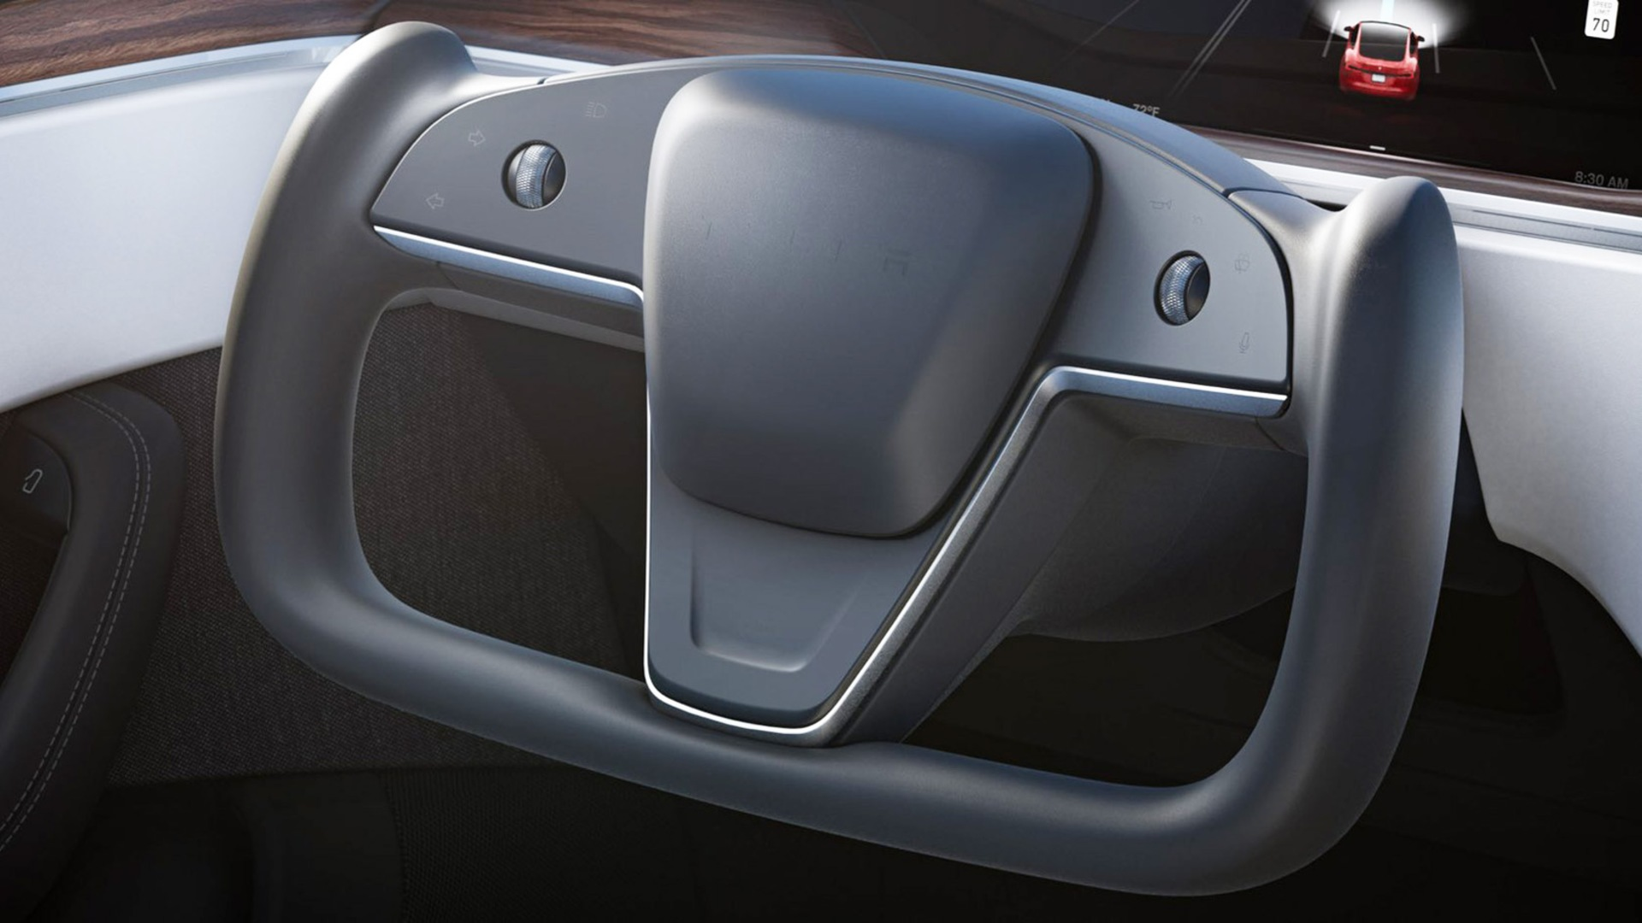

* Auto steer Feature

The auto steer feature is another feature that is yet to be implemented via an update which customers will receive in the near future .

Advertising

When it comes to the Advertising Side of things tesla doesn’t bother to focus on Sales or let alone making many commercials for the car as the features of the car alone is one of the key marketing tactics used by tesla .another source of marketing is done by lending their prototype cars for reviews to popular you tubers or any social media people .